**Issue 1: Game template interferes with idle timeout dialog**

Clicks inside the game are not registering as course activity. From the course player's point of view, user is idle the entire time they are in the game. Accordingly, the idle timeout dialog can appear.

Also, the game screen appears to lie on top of the idle timeout lightbox. Normal display of idle timeout dialog:

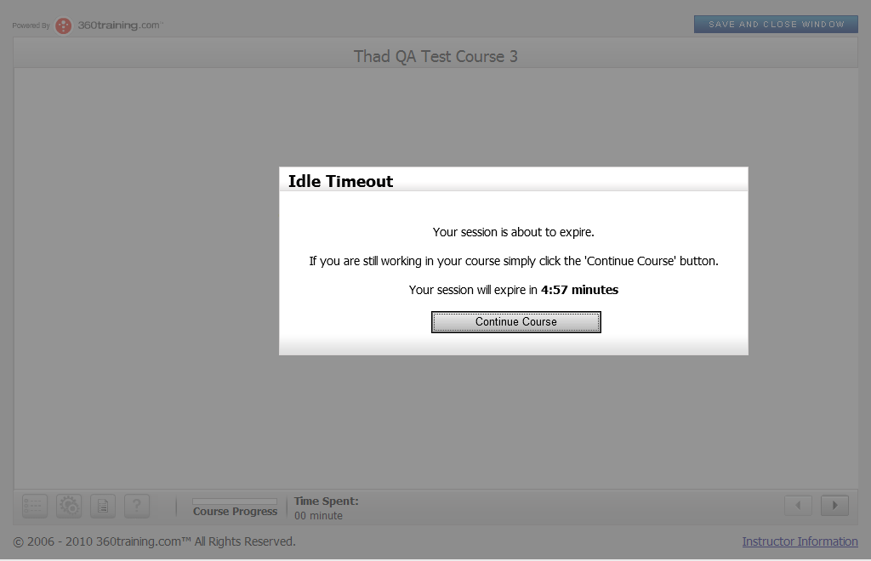

Course timeout dialog appearing while user is in game:

Feedback: Technology feedback requires.

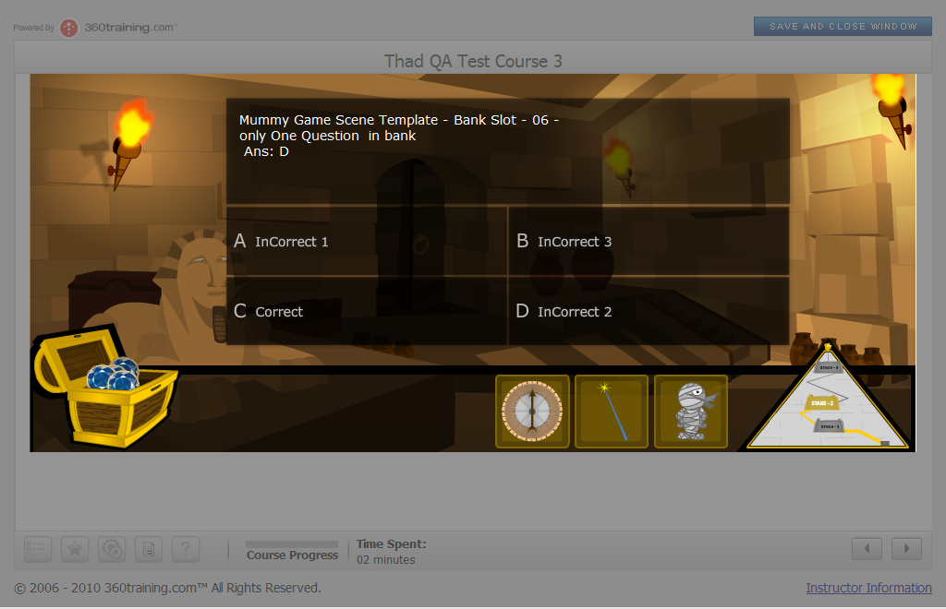

There is no way to click the **Continue Course** button. When **idle timeout countdown expires**, the course player **automatically closes**, which comes as quite a surprise to the user who is in-game when this happens.

Feedback: This issue is fixed in the next release of UAT. Idle timeout window will show on the top of the flash object. That was browser issue.

**Issue 2: Question randomization within bank**

Scenario: user plays Mummy game, loses, and clicks **play again**, repeat 4 times, makes it through level 1 each time. (user never leaves mummy scene between attempts)

Suppose banks attached to slots 1-5 each contain 4 questions.

**Expected results**: questions within banks will appear in random order, and once a given question has appeared in the game, it will not reappear on any other attempt until all 3 other questions in the bank have also appeared once.

**Actual results:** questions are appearing in random order, but the same question sometimes appears on retakes.

Data using banks MummyGameSceneTemplate-BankSlot-02, MummyGameSceneTemplate-BankSlot-03, and MummyGameSceneTemplate-BankSlot-04 (each contain 4 questions):

|  |  |  |  |  |  |  |
| --- | --- | --- | --- | --- | --- | --- |
| Bank | Iteration 1 | Iteration 2 | Iteration 3 | Iteration 4 | Iteration 5 | Iteration 6 |
| Slot # | Question # | Question # | Question # | Question # | Question # | Question # |
| 2 | 2 | 3 | 1 | 3 | 1 | 3 |
| 3 | 2 | 2 | 3 | 2 | 2 | 4 |
| 4 | 1 | 3 | 1 | 3 | 2 | 3 |

As you can see, question #2 from MummyGameSceneTemplate-BankSlot-03 appeared 4 times out of 6. At most, it should have appeared twice. After iteration 4, each question in each of the 3 banks should have appeared once.

Feedback: All Games are functioning accord to same result. Expected result functionality wasn’t in the requirement. Reason, student can play a game multiple times. Hence he/she can see repeated question in any round.

**Issue 3: Answer Choice display**

**First issue**: the fourth line of text spills over the box boundaries. Recommend making font smaller to fit 4 lines of text.

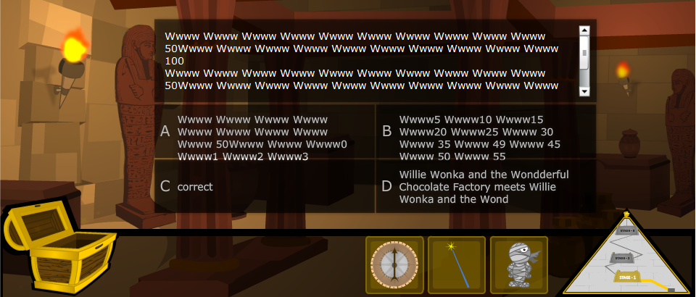

**Second Issue**: text that is too long gets cut off in an odd way – see choice D above.

Why did the last word "Wondderful" get cut off on the 3rd line of text instead of filling out the available space? Same text displays fully on the first line of text. Why didn't the fourth line of text appear in D? Compare with C shown below:

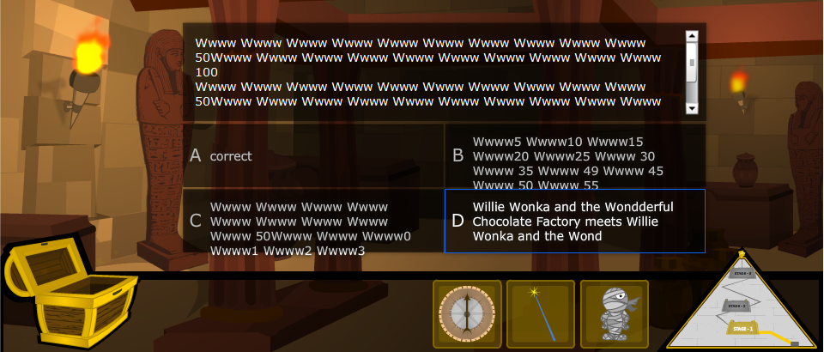

Feedback: We recommended 3 lines only.

**Issue 4: Required elements in LCMS before saving**

1. Is it necessary for the **ID field** in Global Variables to be **required** info? What if I as an author don't want that number showing? Recommend making this optional if possible.

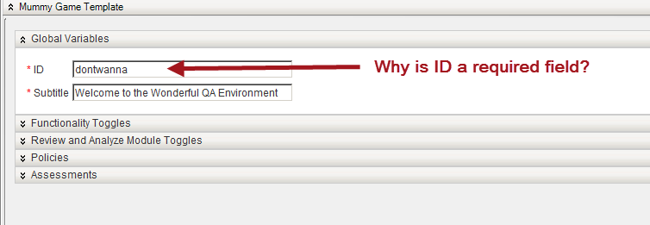

Feedback: Laura comment is required; it can be set on optional field. This field is use only for the author content identification, where they can set content ID to differentiate other game content.

1. You cannot **save** the LCMS Mummy scene template until you have attached all 15 banks. I am not convinced we should change this, as the template is required to have 15 banks attached in order to work; but it can be inconvenient. For instance, I had the scene template halfway filled out and had to leave, but was not allowed to save, so I had to start again from the beginning the next day.

Feedback: In case, he leaves any field as blank and save the form, after that he forgot to update it and run the game. So game will show unexpected errors due to blank fields.

Author should be save all fields of the form in same session. Otherwise validation purpose will destroy.

**Issue 5: misc LCMS course builder concerns**

1. **Subtitle field** accepts no punctuation. Is this on purpose?
2. **Policies**: this is confusing. We need documentation explaining exactly what this does, and how it would differ if you chose quizzes as opposed to post assessment. Also, why is Practice Exam a type?
3. **Assessments**: change this text:  to "Click the **Add Topic** button  to add a topic.

Feedback:

1. All characters are acceptable in the next release of UAT.
2. **Author Responsibility document** will have the instructions. Technology will give us that doc and I have also send a request mail for that document.
3. Laura feedback required.